Dayton Riverfront Master Plan

Request for Qualifications

January 5, 2017

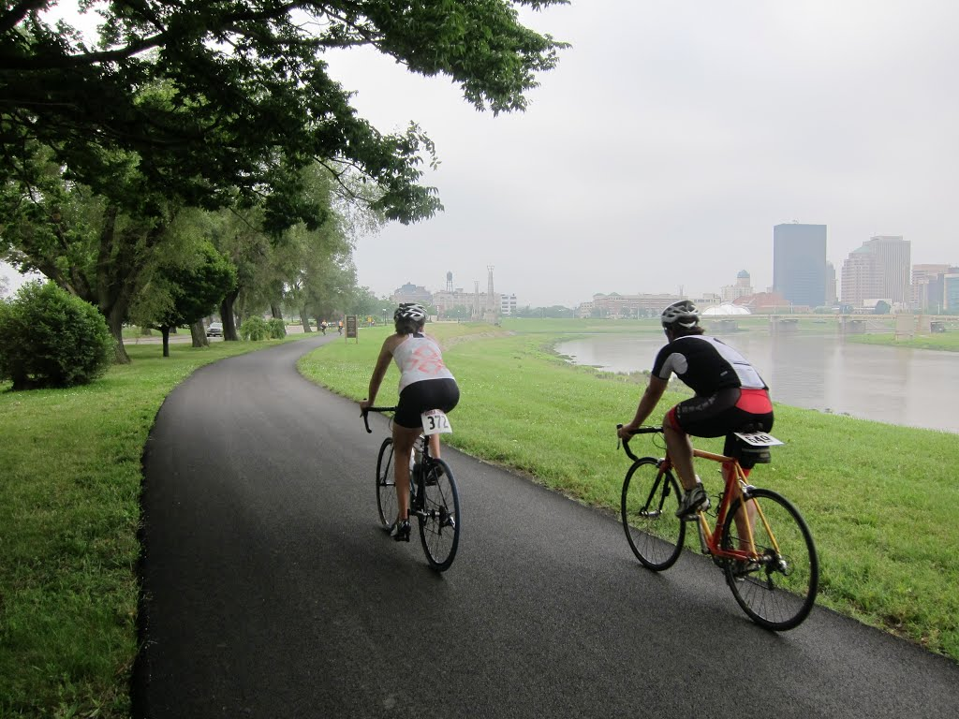 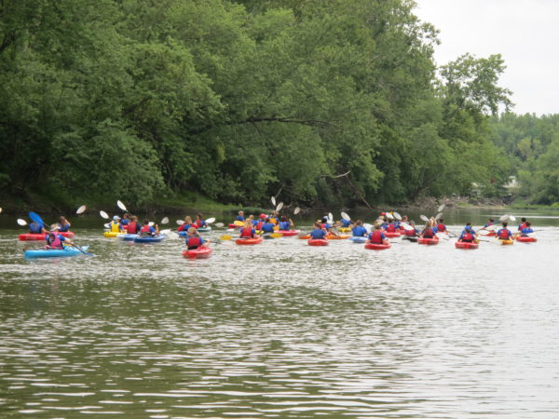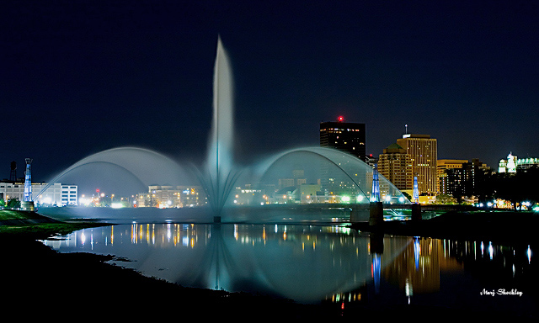

Table of Contents

Dayton Riverfront Master Plan 3

Introduction 3

Project Description 3

Planning Partners 4

Project Goals 4

Scope of Work 5

Submission Requirements 7

Selection Process and Schedule 8

# Dayton Riverfront Master Plan

## Introduction

Five Rivers MetroParks (MetroParks) and project partners are requesting statements of qualifications from qualified consultants to develop a 20-year riverfront master plan (Phase I) and various park site plans (Phase II) for greater downtown Dayton, Ohio.

Questions regarding this RFQ should be addressed to the following:

Carrie Scarff, Chief of Planning and Projects

Five Rivers MetroParks

409 E. Monument Ave., Suite 300

Dayton, OH 45402

937-277-5399

[cscarff@metroparks.org](mailto:cscarff@metroparks.org)

An electronic version of the statement of qualifications (SOQs) is due at the above email address no later than **4:00 p.m., Eastern Standard Time, Friday, January 27, 2017.** SOQs must be received electronically; late SOQs will not be accepted.

Project staff will be available to provide a tour of the site on Tuesday, January 17. Please call Carrie Scarff at 937-277-5399 to arrange details if you would like a tour.

## Project Description

Dayton, Ohio, with a population of approximately 140,000 and a metropolitan area population of nearly 800,000, has four waterways that converge in the greater downtown: the Great Miami River, the Stillwater River, the Mad River, and the Wolf Creek. As downtown Dayton has enjoyed an economic resurgence in recent years, the potential of the riverfront to benefit the community in myriad ways has become compelling. The Greater Downtown Dayton Plan, a multi-partner downtown revitalization effort, recommended the development of a riverfront master plan to address the potential of the downtown waterways. MetroParks has partnered with the City of Dayton and the Miami Conservancy District, as well as Montgomery County, Greater Dayton Regional Transit Authority, Miami Valley Regional Planning Commission, and the Downtown Dayton Partnership to develop that plan.

This riverfront master plan will center on downtown Dayton and extend along its waterways in all four (4) directions of the compass for approximately three (3) miles, each terminating in a park (see exhibit A):

* North on the Miami and Stillwater Rivers to Wegerzyn Gardens MetroPark
* East on the Mad River to Eastwood MetroPark
* South on the Great Miami River to Carillon Historical Park
* West on the Wolf Creek to Wesleyan MetroPark

The study will address the waterways themselves, the beaches, levees, public parks and open space, as well as potential land use and zoning opportunities adjacent to the corridor. The majority of land within the corridor is owned by the City of Dayton or the Miami Conservancy District, the regional agency responsible for flood control. The primary purpose of the levees and the land within the levees is flood control, and all proposed land uses and development within these areas must be consistent with the flood control requirements and restrictions of the Miami Conservancy District.

The existing community assets within the project corridor are numerous. At least twelve public parks fall within the corridor along with additional open space in public control, and significant cultural amenities include the Dayton Art institute, the Boonshoft Museum of Discovery, the Masonic Temple, and Carillon Historic Park. The University of Dayton and Sinclair College are included in the corridor, as are satellite facilities for Wright State and Central State Universities. The Dayton region is home to the largest paved trail network in the nation, and the entire plan area includes a bikeway on one or both sides of the waterways. These bikeways carry the North Country Scenic Trail and the Buckeye Trail to the east and north of downtown. Each of the three rivers is a National and State Designated Water Trail, and Dayton is has been designated a Bike-Friendly City by the League of American Cyclists. The cycling and paddling communities in the greater downtown are very active, and for this and other reasons, Dayton has been dubbed the Outdoor Adventure Capital of the Midwest.

The master plan will address access and connectivity to and along the waterways and quality open spaces and recreation opportunities that will benefit public health and social justice. Improving environmental quality and reducing flood risk are priorities as well. Ultimately, urban vibrancy and placemaking along the corridors will lead to the highest goal of community economic development.

## Planning Partners

The planning area is contained within the city of Dayton and a number of city parks are within the corridor; Five Rivers MetroParks also operates a number parks within the boundaries of the study; the Miami Conservancy District owns much of the land within the corridor and exercises flood control rights throughout. These three governmental agencies are the primary partners in the Riverfront Master Plan. Other partners include Montgomery County, Greater Dayton Regional Transit Authority, and Miami Valley Regional Planning Commission, the area’s metropolitan planning organization, and the Downtown Dayton Partnership, the non-profit organization charged with downtown economic development. These seven organizations will make up the project steering committee which will provide strategic direction and project oversight.

The core working committee will work closely with the consultant and will be composed of representatives from the three primary partners and two to three other individuals. An expanded working committee, approximately 15 people, will include representatives from all project partners addressing various dimensions of the project and these people will be brought in as needed. Carrie Scarff, MetroParks’ Chief of Planning and Projects, will serve as project manager and will manage the contract and serve and the consultant’s point of contact.

## Project Goals

Project following goals areas for the riverfront master plan have been established. Goal statements will be finalized as part of the master planning process

* Community economic development
* Urban vibrancy and placemaking
* Identity and re-imaging
* Open space and recreation opportunities
* Accessibility—physical, visual, and perceptual
* Connectivity
  + Greenways and blueways
  + Walkability, bike-ability, paddle-ability
  + Rivers as connectors, not dividers
* Flood risk reduction
* Environmental quality
* Public Health
* Social justice

## Scope of Work

The prescribed scope of work is designed to give the consultant flexibility in proposing a project approach. Required elements of work and aspects of the project to be contributed by the client team are listed below.

Phase I: Master Plan

* Existing Conditions: The consultant will synthesize information gathered and provided by the client. Information to be provided by the client includes the following:
  + Project base mapping (GIS format)
  + Existing land use & zoning
  + Existing plans, policy documents, regulations and restrictions
  + Proposed improvement projects within or adjacent to the corridor
  + Previous riverfront plans

The consultant will gather and synthesize additional information, including that listed below.

* + Demographic conditions and trends
  + Socio-economic conditions and trends
  + Additional information as required to fully inform the master planning process

Deliverables: Report with any necessary narrative, maps, graphics and images that fully summarize all existing conditions data relevant to the master plan and subsequent key observations and conclusions.

* Public & Stakeholder Input: The consultant will conduct a thorough public input process to include interviews with partners (7) and key stakeholders (approximately 8) at a minimum and facilitate public input through a variety of methods that allow for comprehensive input from stakeholders up and down the corridors and the general public in the region. Working committee staff will aid in the input gathering process and will host a web-based information site. Corridor stakeholders include the following:
  + Approximately 19 adjacent neighborhoods
  + Approximately 10 educational and health care institutions
  + Approximately 10 civic groups and clubs
  + Private businesses, land owners, developers, and adjacent municipalities

Deliverables: Report that summarizes public and stakeholder input gathering methods, results, and key observations and conclusions; appendices that provide full input data.

* Project Goals and Objectives: Based on information gathered in the existing conditions and public input phases, review the master plan’s goal areas provided by the client and finalize project goals.

Deliverables: Final master plan goals.

* Plans, Recommendations, and Implementation Strategies: the recommendations will address each of the master plan goals and will include mapping and narrative components. The consultant will provide draft alternative components for review and comment by the Steering Committee and Core Working Committee. The final Plans, Recommendations, and Implementation Strategies that meet the project goals will be accompanied by a capital improvement phasing plan, capital project cost estimates, and funding alternatives. Elements in the Plans, Recommendations, and Implementation Strategies may include:
  + Open space, parks, and recreational amenities
  + Public facilities
  + Multi-modal transportation, circulation, linkage, and access elements
  + Urban design form and character
  + Zoning and land use
  + Water quality and habitat enhancements
  + Flood risk reduction
  + Infrastructure
  + Others

Deliverables: Report including narrative, maps, sketches, images, and other data to convey the plan’s recommendations, implementation strategies and funding alternatives; a capital improvement phasing plan; capital project cost estimates.

Phase II: Park Site Plans

Ten-year site plans will be prepared for various parks in the Five Rivers MetroParks system along the corridor:

* Island MetroPark
* Deed’s Point MetroPark
* RiverScape MetroPark
* Sunrise MetroPark
* Wesleyan MetroPark

Additional parks or open space may be added to the list and fees negotiated if, during the course of master plan development, additional sites are chosen for site plans.

In April 2016, Five Rivers MetroParks (FRMP) completed its 10-year Comprehensive Master Plan (CMP). Copies of the plan can be found at [www.metroparks.org/plan](http://www.metroparks.org/plan). This plan included significant community input, benchmarking of other park agencies, and agency wide staff participation. The CMP developed a new park typology which outlines how each park fits within the overall system, the balance between human and ecosystem, as well as the level of development that occurs with each park type (Chapter 2, Section 11). The CMP also outlines recommendations that will impact the development of the park site plans (Chapters 3 and 4) and park and facility assessments (Appendix C). Public, stakeholder, and staff feedback and a statistically valid survey indicated the highest priorities of the community (Chapter 2, Sections 1-6). Consultants will be expected to familiarize themselves with the CMP and incorporate its recommendations in the site plans of MetroParks facilities.

The consultant shall include the following elements in the site planning process:

* a public input component that addresses all site plans collectively
* park program for review and approval
* minimum two site plan alternatives for review and comment

The site plans will be one component of the park’s master plan. MetroParks will develop the other components of the master plans concurrent with or subsequent to the site planning process. These components include the following:

* Interpretive Plan
* Natural Resources Plan
* Proposed Staffing Level of Service
* Operating costs and projected revenue opportunities
* Cost of Service Estimates
* Cost Recovery Goals
* Business Plan (if needed)
* Land Acquisition Plan (if needed)

The following work will be performed or provided by MetroParks:

* Provide previous park master plans or site plans, MetroParks Comprehensive Master Plan, and other documents relative to the subject parks
* Provide additional GIS data as required (soils, topography, utilities, boundaries, aerial photos [MrSID format] and existing improvements)
* Schedule and publicize public input sessions
* Provide compiled public input surveys collected online and in parks

Final Deliverables

The consultant will deliver the elements listed below at the conclusion of Phase II of the project.

* Ten hard copies of the master plan and four hard copies of the site plans with narrative and mapping elements and appendices, including all data and sections listed above. One electronic .pdf version of the same.
* GIS files for all mapping components of the plan
* Capital improvement plan including phasing and cost estimates

## Schedule and Fees

The project will be completed in 12 months. Details of the schedule will be determined during contract negotiations.

The project budget, currently estimated at $340,000, must cover all expenses, including reimbursable expenses. Additional funding may come to the project for site planning during 2017. The consultant shall base the scope of work described in the project approach in their submittal based on the currently estimated project budget.

## Submission Requirements

The statement of qualifications shall include the elements listed below. Ohio Revised Code requires that public agencies select consultants on the basis of qualifications only. Consultants shall not include fees in their statement of qualifications.

* Project Approach: description of your project approach, including familiarity and understanding of the project, key aspects of the project, scope of work, client communication, deliverables, and project schedule.
* Project Team: a description of the prime consultant and subconsultants, including project roles and areas of expertise and experience. Include resumes of key staff assigned to the project. Identify individual staff’s specific role on the project, including the principal-in-charge and project manager. Highlight experience in riverfront master planning.
* Hourly rates: rates of all positions within the firm for prime consultant and any proposed sub-consultants.
* Benchmarking Projects: examples of five (minimum) similar projects the prime consultant and/or subconsultants have performed including the firm’s role, scope of responsibility, total project scope, total project cost, cost of your firm’s scope, and client contact information.
* Capacity: The team’s capacity to perform the work, including the size of the firm(s), availability of key staff in terms of percentage of time available to devote to the various phases of this project, and a list of projects in progress with due dates and key staff’s percent time devoted to those projects.
* References: at least three client references including full contact information from work performed in the past three years.

Statements of qualifications should total no more than 30 pages. All submissions shall be electronic via email, Dropbox or other file sharing method. It is the responsibility of the submitter to ensure that any submission method is successfully received by Five Rivers MetroParks by the submission deadline. Late submissions will not be accepted.

## Selection Process and Schedule

Consultant selection will be made based on the project requirements and the criteria outlined in this RFQ, including experience in meeting similar project goals. Five Rivers MetroParks reserves the right to reject all submittals, to negotiate a select portion of the scope described, and to develop a short list of interested firms and interview that short list as a second step of the selection process. MetroParks will enter into negotiations with the preferred firm regarding scope of work and fees. Should agreement on scope and fees not be reached, MetroParks will move to the next preferred firm. The intent is to select a consultant and come to terms in March 2017. The contract will be based on MetroParks’ Standard Form Agreement (Exhibit B).

# Exhibit A

# cid:07CE03EB-B9E7-4842-85F6-6C76305BCCDD@metroparks.org

# Exhibit B

**PROFESSIONAL SERVICES AGREEMENT  
FOR**Project Name

AGREEMENT made as of this **9/30/2016**  
BY AND BETWEEN   
**Click here to enter Consultant Name** (“Consultant”)  
AND  
Five Rivers MetroParks (“MetroParks”)  
TYPE OF AGREEMENT: Professional Services Contract

**WHEREAS,** Five RiversMetroParks desires Click here to enter text.**;** and

**WHEREAS,** Consultant is in the business of providing such services and desires to provide such services to MetroParks; and

**NOW, THEREFORE,** in consideration of the mutual covenants and promises contained herein, the parties hereto agree as follows:

**1. SCOPE OF WORK**

1.1 Consultant shall conduct the services as set forth in **Click here to describe the project, reference an attachment or appendix if applicable**;(hereinafter the “Services”).

**2. TIME OF PERFORMANCE**

2.1 Consultant shall promptly commence and diligently pursue completion of the Services upon receipt of one copy of this Agreement signed by the authorized representative of all parties, which shall constitute the notice to proceed.

**3. FEES AND PAYMENT**

3.1 In consideration of the Services performed, MetroParks shall pay the Consultant according to the rates listed below.

3.2. Consultant agrees that the aggregate consideration for the Services shall not exceed $, without the prior approval of MetroParks.

3.3 Payment terms shall be net 30 days from the receipt of the invoice. Invoices should be forwarded to the address in Section 20.1 faxed invoices will not be accepted. MetroParks is a tax exempt organization in the State of Ohio.

3.4 Only one invoice should be submitted per month.

**4. CONFIDENTIAL INFORMATION**

4.1 Except as required by law, any information identified by MetroParks that any employee or agent of Consultant gathers or otherwise gains access to during the course of the Services, as well as any analysis, findings or conclusions made by any employee or agent of Consultant in connection with the Services, shall be kept confidential and shall not be revealed to, or discussed with, anyone other than the following persons:

a. Other employees or agents of Consultant who are participating in the Services on a “need-to-know” basis only;

b. **Eric Sauer, Planning Manager**;

c. Any other person designated by those persons listed in 4.1b.

MetroParks will clearly identify information presented to the consultant or provided by the consultant that must remain confidential.

4.2 The confidentiality provisions of this Agreement shall not apply to information that was or becomes generally available to the public other than as a result of a disclosure by an employee or agent of Consultant.

4.3 Consultant shall indemnify, defend, hold harmless, and reimburse MetroParks for and against any losses, expenses, damages or other liability, including reasonable attorneys’ fees, incurred by MetroParks as a result of and to the extent of any violation or breach by Consultant of the confidentiality provisions of this Agreement.

4.4 This Section 4 shall be binding upon the parties hereto and upon their successors and assigns and shall survive the termination (for any reason) of Consultant’s provision of the Services.

4.5 In the event Consultant receives a request, including a subpoena or similar legal inquiry, to disclose information subject to the confidentiality provisions of this Agreement, Consultant shall provide MetroParks with 3-5 days’ notice so that MetroParks may seek appropriate protective relief.

**5. CONSULTANT’S RESPONSIBILITIES**

5.1 Consultant agrees to comply with all applicable federal, state, and local laws, rules, regulations, orders, codes, and standards in performing the Services hereunder.

5.2 Consultant agrees to provide copies of certification of the Consultant’s insurance coverage to MetroParks.

5.3 Consultant agrees to assign qualified personnel to perform the Services under this Agreement.

5.4 Consultant agrees to assume all liability to the extent caused by its negligent acts or willful misconduct for its activities on or about the Property, to undertake appropriate safety precautions, and to fully inform, supervise, train and equip its employees, representatives, agents, Consultants or subcontractors to perform the Services.

**6. METROPARKS’ RESPONSIBILITIES**

6.1 MetroParks shall provide access to the Property, at reasonable times, to enable the performance of the Services by Consultant.

6.2 MetroParks shall provide Consultant reasonable access to all available information and data in MetroParks’ possession concerning the Services under this agreement.

**7. REPRESENTATIONS AND WARRANTIES**

7.1 The Consultant shall perform in a manner consistent with that degree of care and skill ordinarily exercised by members of the same profession currently practicing under similar circumstances at the same time and in the same or similar locality.

**8. INDEMNIFICATION**

8.1 Consultant shall indemnify, and hold harmless, MetroParks, and its respective officers, directors, affiliates, partners, and employees against all claims, damages, losses, and expenses, including but not limited to, reasonable attorney’s fees and charges, and court and arbitration costs, arising out of or in any way connected with or related to: (a) Consultant’s breach of this Agreement; or (b) personal injury, illness, death, economic loss, and property damage arising out of the negligent performance of the Services.

**9. TERMINATION**

9.1 This Agreement may be terminated in whole or in part by either party at any time upon thirty (30) days prior written notice to the other. Consultant shall cease work on the termination date and shall not incur further expenses in connection with the Services. MetroParks shall pay Consultant for all Services performed under this agreement.

**10. GOVERNING LAW**

10.1 This Agreement shall be governed by and construed in accordance with the laws of the State of Ohio regardless of the laws that might otherwise apply under Ohio principles of conflicts of law.

**11. INDEPENDENT CONSULTANT**

11.1 Consultant shall not be deemed to be the employee or agent of MetroParks.

**12. INSURANCE**

12.1 During the term of this Agreement, Consultant and/or it’s subcontractors shall maintain at its expense, , insurance with respect to its property and business against such casualties and contingencies, of such types and in such amounts, as is customary for established companies engaged in the same or similar business as the Services and similarly situated as Consultant, with financially sound and reputable insurers. Maintenance of such insurance will not relieve Consultant of any liability under this Agreement. Consultant agrees to furnish MetroParks with certificates issued by the insurance company or companies issuing insurance required by this Agreement.

**13. NON-WAIVER OF BREACH**

13.1 No waiver of any breach or default of this Agreement shall operate as a waiver of any similar subsequent breach or any breach of any other provisions of this Agreement.

**14. USE OF METROPARKS’ NAME**

14.1 Consultant shall not use MetroParks’ name in connection with any other project, proposed project, advertising brochure, or other commercial use without the prior written consent of MetroParks.

**15. SEVERABILITY**

15.1 If any provision of this Agreement is held invalid by a court of competent jurisdiction, such provision shall be severed from this Agreement and, to the extent possible, this Agreement shall continue without effect to the remaining provisions.

**16. ASSIGNMENT; SUBCONTRACTORS**

16.1 No party may assign or transfer this Agreement or any rights or duties hereunder without the written consent of the other parties.

16.2 Consultant shall not engage a subcontractor to perform any portion of the Services without MetroParks’ prior written approval.

16.3 Consultant shall be solely responsible for the satisfactory performance of any portion of the Services by the subcontractors. No contractual relationship shall exist between MetroParks and any subcontractor with respect to the Services to be performed hereunder.

**17. SURVIVAL**

17.1 The promises and covenants set forth herein, including without limitation the confidentiality obligations and indemnification, shall survive the expiration or termination of this Agreement, for any reason.

**18. FORCE MAJEURE**

18.1 Consultant shall not be liable for any delay or failure in completing performance of the Services under this Agreement to the extent that such delay or failure was the result of an act of God, war, government, labor unrest, or denial of access to any Property or any other factors beyond Consultant’s control which could not readily have been foreseen by Consultant.

**19. CAPTIONS AND HEADINGS**

19.1 The captions and headings throughout this Agreement are for convenience and reference only, and the words contained therein shall in no way be held or deemed to define, limit, describe, modify, or add to the interpretation, construction, or meaning of any provision of or scope or intent of this Agreement.

**20. NOTICE**

20.1 Any notice given by either party shall be in writing and shall be given by facsimile or overnight delivery service to the other party at the following addresses:

|  |  |
| --- | --- |
| To MetroParks Correspondence | ATTN: Eric Sauer, Planning Manager  Five Rivers MetroParks  409 E. Monument Ave, 3rd Floor  Dayton, OH 45402  Email: eric.sauer@metroparks.org |
|  |  |
| To MetroParks Invoicing  (faxed invoices will not be accepted) | Attn: Accounts Payable  Five Rivers MetroParks  409 E. Monument Avenue, 3rd Floor  Dayton, OH 45402  Email: [accountspayable@metroparks.org](mailto:accountspayable@metroparks.org) |
|  |  |
| To Consultant | ATTN: Click here to enter Consultant name  Click here to enter Company name  Click here to enter Company address  Click here to enter Company City State, Zip  Click here to enter Consultant email |

**21. ENTIRE AGREEMENT**

21.1 The parties acknowledge that they have read this Agreement (together with material incorporated by reference herein), understand it, and agree to be bound by its terms and further agree that it is the entire agreement between the parties and supersedes all prior agreements, written or oral, relating to the subject matter hereof. No modification or waiver of any provision shall be effective unless it is in writing and is signed by the party against whom such modification or waiver is sought to be enforced.

**22. COUNTERPARTS**

22.1 This Agreement may be signed in counterparts, each of which shall be deemed an original, and all of which shall together constitute one and the same Agreement.

**23. ASSURANCES**

23.1 The Consultant agrees that duly authorized representatives of MetroParks shall until the expiration of sixteen (16) years after final payment under this Agreement, have access to and the right to examine any directly pertinent books, documents, papers, and records of the Consultant involving transactions or services related to this Agreement.

23.2 Original documents, charts, computations, and other data prepared or obtained under the terms of this Agreement or any change orders are and will remain the property of MetroParks unless otherwise agreed to by both parties.  MetroParks may use such documents for other purposes without further compensation to the Consultant; however, any reuse without written verification or adaptation by the Consultant for the specific purpose intended will be at MetroParks’ sole risk and without liability or legal exposure to the Consultant.

23.3 The services agreed to be provided by the Consultant within this Agreement are for the exclusive use of MetroParks and the Consultant and shall not engage in conflict of interest nor appropriate MetroParks work product or information except for knowledge in the public domain for the benefit of any third parties without MetroParks’ consent or if disclosure is reasonably necessary for the Consultant to defend itself from any legal action or claim.

23.4 The Consultant will perform the specified professional services within the term as specified in Section 25 using due and reasonable diligence consistent with sound professional practices. The proposed work schedule can be adjusted as appropriate to better meet the needs of MetroParks upon written agreement by both parties.

**24. LIMITATIONS ON LIABILITY**

24.1 The total liability of Consultant, its employees, officers, directors, agents, and subcontractors, to MetroParks and its insurers or anyone claiming by, through or under them arising out of or in connection with this Agreement for any special, indirect, economic or consequential damages, including but without limitation, loss of profits or revenue, loss of use of any facility or property, including real property, cost of capital, loss of goodwill, or similar damages will not exceed $500,000, provided that the limitation shall not apply to the extent such losses or damages result from gross negligence, willful misconduct, reckless misconduct, wanton misconduct, or intentional acts. MetroParks will not be liable to Consultant for any special, indirect, economic or consequential damages, including but without limitation, loss of profits or revenue, loss of use of any facility or property, including real property, cost of capital, loss of goodwill, or similar damages in excess of $500,000, plus the price of the Services, provided that the limitation shall not apply to the extent such losses or damages result from gross negligence, willful misconduct, reckless misconduct, wanton misconduct, or intentional acts.

24.2 This Section 24 will (i) apply to the fullest extent allowed by law irrespective of whether liability is claimed, or found to be based in contract (including breach of warranty or contract), tort (including negligence or negligent misrepresentation), strict liability, or otherwise, and (ii) survive the completion of the services or the expiration, cancellation, or termination of this Agreement.

**25. TERM AND RENEWAL OF AGREEMENT**

25.1 The term of this agreement is **Click here to enter dates of agreement.**.

25.2 **Choose an item.**

25.3 **Choose an item.**

**IN WITNESS WHEREOF,** the parties hereto have caused this Agreement to be executed by their duly authorized representatives as of the date first written above.

|  |  |
| --- | --- |
| **FOR** Click here to enter Company name  ______________________________________  Signature  ______________________________________  Name (Print)  ______________________________________  Title  Dated as of _____________________, 2016 | **FOR FIVE RIVERS METROPARKS**  ______________________________________  Signature  ______________________________________  Name (Print)  ______________________________________  Title  Dated as of _____________________, 2016  **CERTIFICATION OF FUNDS**  ______________________________________  Signature  ______________________________________  Name (Print)  ______________________________________  Title  Dated as of _____________________, 2016 |